- Open to: ALL STUDENTS AND TEACHERS
- Directions: Create an obstacle course (indoor, outdoor, or both) for you and your parent to go through. This obstacle course must have at least one obstacle for you to jump over, one obstacle for you to crawl under or through, and at least 6 other obstacles (8 Total). Be creative with your obstacles but you can only use items that are found in your house/yard. REMEMBER, SAFETY FIRST! NO DANGEROUS STUNTS! The purpose is to have fun and get exercise. Your obstacles may include puzzles, math problems, spelling words, reciting memory verses, finding memory verses, etc. BE CREATIVE!! Have someone video the student and an adult going through the obstacle course and email it to Coach Overcash at Brandon.Overcash@BCACrusaders.org. The winner of the Crusader Creative Obstacle Course Challenge will receive a prize when we return to school! Your video is due back to Coach Overcash by March 29th.
- Video Due: Must be emailed to Coach Overcash by March 29th.
- Winner: The winner of the Crusader Creative Obstacle Course Challenge will receive a NEW BCA LOGO LED LIGHT!

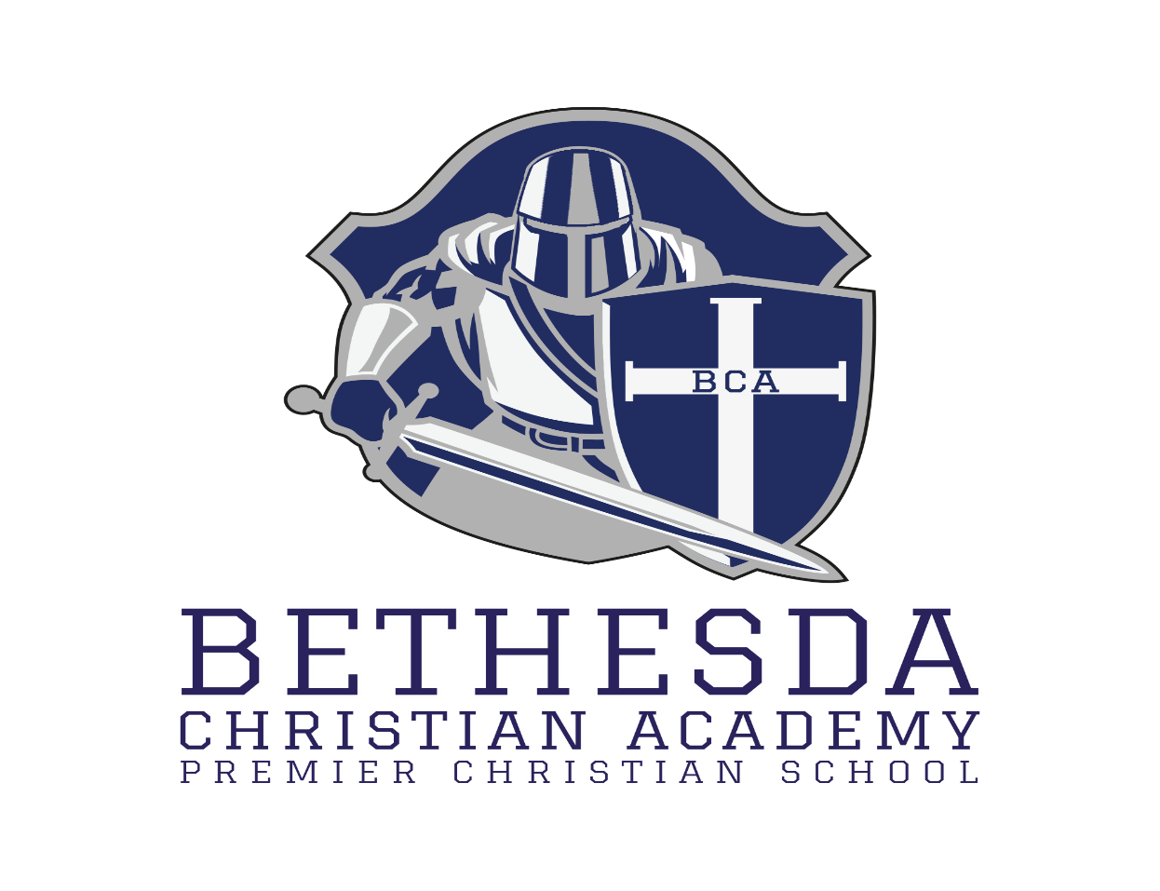
Good luck and may the best Crusader Win!!!

